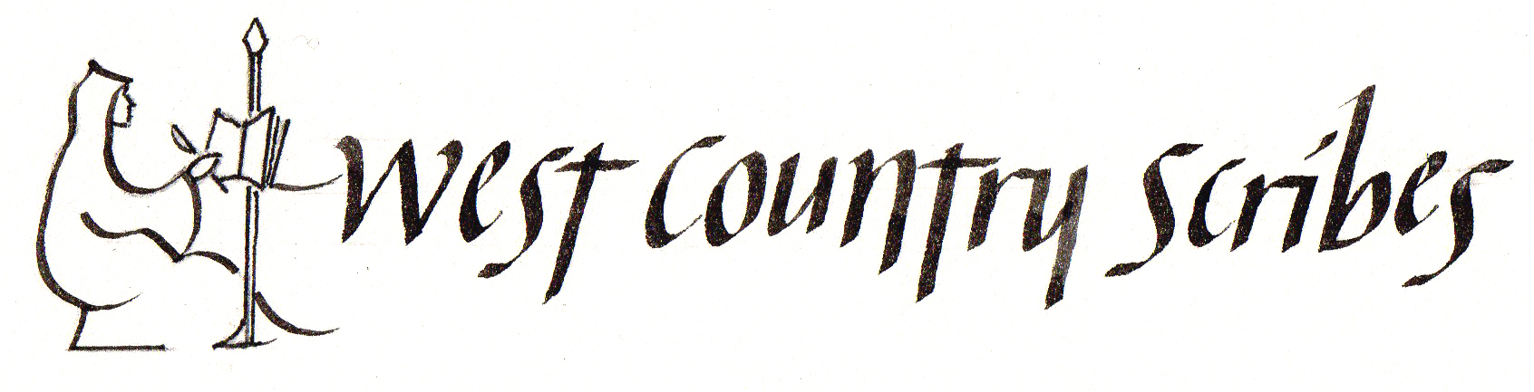

Jan Mehigan
GILDING AND ILLUMINATION
Calligraphy Workshop on Saturday, 15 July 2017
9.45am to 4.00 pm
Rockwell Green Village Hall, Rockwell Green, Wellington TA21 9BU
Learn the techniques of illumination (gilding) and enjoy creating your own decorated and illuminated letters or decorative motif , which can perhaps be used to enhance your calligraphy, illuminate a miniature or create a single, vibrant decorative letter, using line, colour and gold ( the “real” stuff or gold gouache). Even the smallest amount of gold added to work makes it stunning. We will work on paper for the day.
You may wish to bring your own exciting design or perhaps select from the design resources provided. Letters and patterns will be drawn with a pencil or created with a technical pen. The gold will be laid on PVA and maybe gesso. This workshop is for all levels.

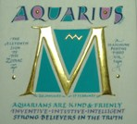 | 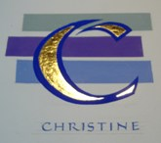

WHAT YOU CAN BRING ON THE DAY:
Pencil, pen, eraser, ruler, masking tape or 3M Magic tape, craft knife or scissors. You will only need to bring a small amount of white Hot pressed (smooth) watercolour paper: 140lb or 260 HP – either: Waterford or Fabriano – (two of A5 or A4 size will be plenty for finished work). Buy a sheet and divide between 4 or maybe 8 people.
You will need a small amount of Layout or photocopy paper and tracing paper for planning a design or letter.
You may wish to bring your own size (PVA) and gold, shell gold or gold powder, real or otherwise, however, I will be very pleased to supply these items**

You will actually require:
2H and HB pencil

An inexpensive black technical pen would be useful (optional & costs about 1.50 or alternatively, a dip pen with No. 4, or fine nib).

A small selection of gouache and watercolour paints
Two Paint brushes with good points: (No. 2, plus a finer brush a 00 or perhaps a 000).
An old paint brush (or two) for mixing paint would be very useful.
Quality Paper - about ¼ sheet only. (Waterford or Fabriano Artistico Hot Pressed Paper 1401b or better still 260lb)
Layout Paper - or two or three A4 sheets of photocopy paper
One or two sheets of Tracing paper
Two water pots and kitchen towel for wiping brushes
A mixing palette or white plate or similar

**Transfer Gold leaf, PVA and gesso will be available to purchase from the tutor to add a sparkle to your work and the day!! The transfer gold will be £2.00 per sheet. Also available will be a couple of burnishers to share , some agate stones and pieces of silk with which to polish the gold

To book please telephone Sara Jennings on 01823 338253
or email jenningsron@outlook.com
Find us at www.westcountryscribes.co.uk

