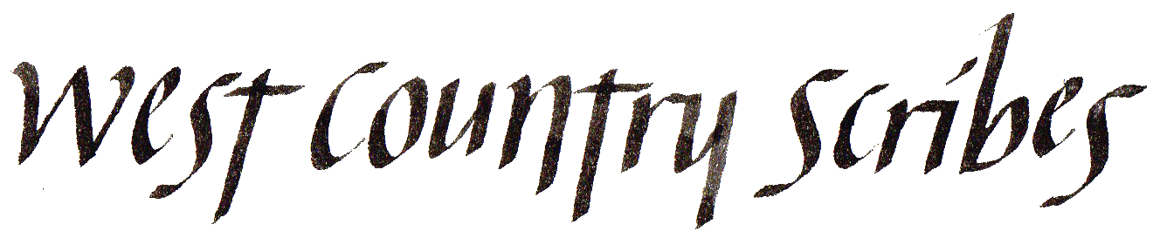

We offer a varied programme of workshops with tutors of high repute for all who wish to develop their Calligraphy skills

Our workshops are held in
Rockwell Green Village Hall, Popes Lane, Wellington TA21 9BU

with excellent lighting, tea and coffee facilities and free car parking.

Membership fees Will be adjusted down for 2020 and 2021, according to number of meetings, and will be advised in due course..

Membership fees cover our cost of venue hire, and secure our future, so newcomers are requested to become members after 2 attendances.

Workshop times - arrival 9.45am for 10am start, until 4pm. Please bring your own packed lunch to eat during the lunch break.
Workshop fees
Tutored workshops – £25
Untutored Practice Days & AGM – £10

Untutored Practice Days are friendly get-together days where, in the company & support of fellow members, we can practice scripts or techniques from past workshops, or develop our own calligraphy projects.

To book a place on a workshop contact:
Bee Ottway – phone 01458 830172
or Email: barbaraottway@gmail.com

www.westcountryscribes.co.uk
UPDATED PROGRAMME 2021

We will start as soon as possible when restrictions allow. According to current rules (March 2021), more than 6 people cannot meet indoors until after 21 June.

Our first meeting on resumption will commence with a group get-together, chat, cake & refreshments, followed by individual practise. This will be a free meeting, with no charge, to welcome everyone back.

If we cannot hold a June meeting, the above will all take place as a first meeting on 17 July.

19th June Welcome get-together, short AGM and practise day (No charge)

17th July Untutored Practise Day

21st Aug Untutored Practise Day

18th Sept LEGENDE
Mark D’Argent

16th Oct Bookbinding - Nesta Davies

20th Nov MOUSE ROMAN
Josie Brown

11th Dec AGM
followed by a shared lunch and calligraphy practice

Membership Fees will be confirmed when we know what date our meetings can resume.

Exploring Watercolour and Watercolour Media with Eva Boston is postponed to 2022.

Italic Minuscules with Dee Howley-Gibbs will be held March 2022.

Celtic Half Uncials with Gillian King also postponed – perhaps to 21 August this year if the group wishes.

19 June Possible Welcome Back & short AGM

17th July Untutored Practice Day
(or as above if June cancelled)

21st Aug Untutored Practice Day

18th Sept Legende, Mark L’Argent

16th Oct Bookbinding, Nesta Davies

20th Nov Mouse Roman, Josie Brown

11th Dec AGM + Shared Lunch

Our website will give full details of any programme changes, coronavirus information and other details.

to become a member, please contact: Sue Donaldson (Treasurer)
Ryalls Orchard, Saltmoor, Burrowbridge TA7 0RJ
Email: susanhyam@aol.com
Phone: 01823 698362

